Name: G. Ramya Course code: CSA0307(Data Structures)
Reg no:192572073 Slot: A
C01 AT3 (OUTPUT VERIFICATION)

1.
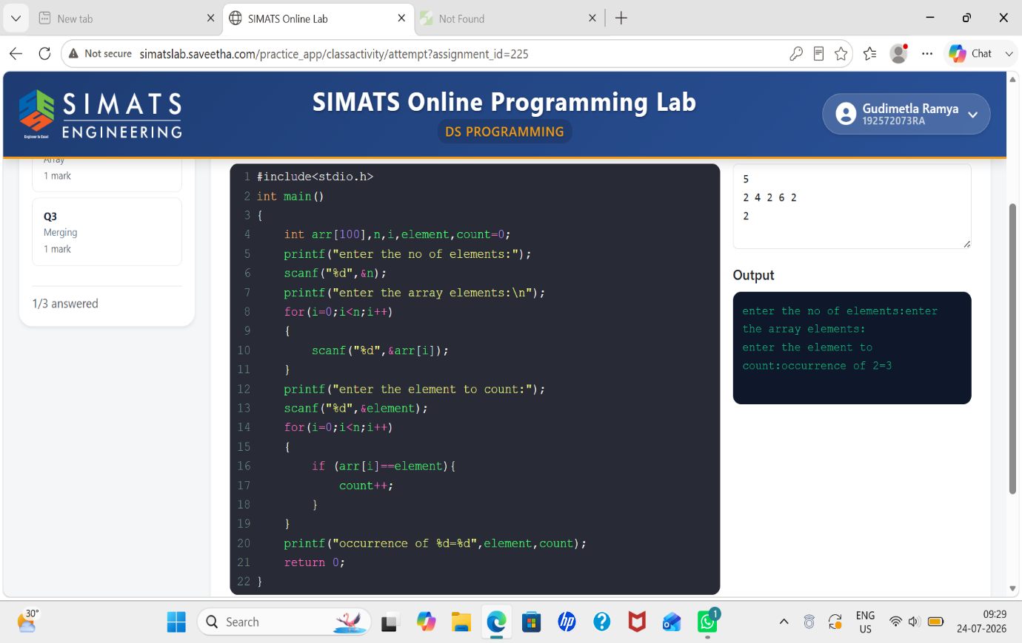

2. 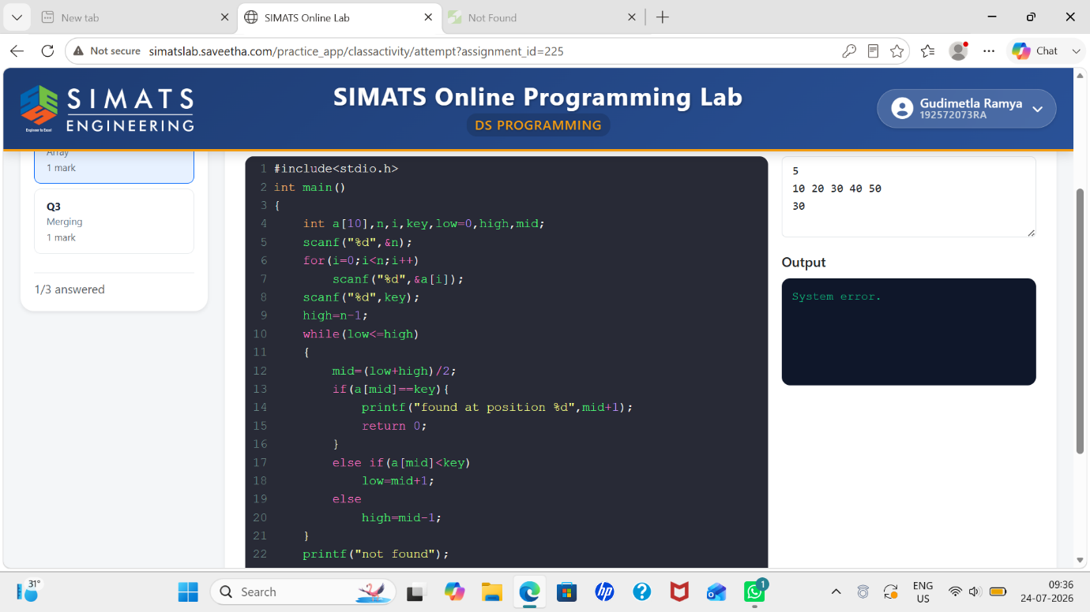
3.
